TeamUCL Access Statement

Bloomsbury Fitness Club

Contents
- Venue Statement
- Travel to the venue
- Venue map
- Accessible features at the venue
- Additional information

Venue Statement

Thank you for taking an interest in our club. We are committed to making UCL an inclusive community and supporting all disabled students taking part in our activity. The Welfare Officer of every sports club has been trained in Disability Inclusion and Etiquette Training. We have completed this form to try and support you joining the TeamUCL community.

If any of this information is unclear or you would like more information on other venues or activities are club get up to, please email teamucl@ucl.ac.uk.

Travel
Bloomsbury Fitness is easily accessible using all modes of transport. Click here for the Tfl Accessible Tube Map

Underground
Unfortunately, few of the underground or mainline railway stations around Bloomsbury Fitness are fully wheelchair accessible.
However, some ambulant disabled supporters/visitors may be able to use them.
• Euston Square Station (Hammersmith and City Line, Circle Line, Metropolitan Line) is the nearest tube station and is around a three minute walk from the facility. This station has the smallest step and gap and are suitable for most customers including wheelchair users.
• Tottenham Court Road station (Northern Line) is around a 15 minute walk from the facility.
• Kings Cross Saint Pancras and Euston Station (London Overground and Great Northern Rail) is around a 10 minute walk from the facility. Note: There are manual ramps that are on that you can book in advance. If you plan to travel on London Overground or TfL Rail, staff will be available at stations to assist you with your journey. You can pre-book assistance by calling 0343 222 1234*.

Buses
All Transport for London (TFL) bus routes are wheelchair accessible and have clearly marked priority seats for people with limited mobility. On most buses the wheelchair ramp is positioned at the exit door and there is one wheelchair user place on each bus. The main bus routes that stop close to Bloomsbury Fitness are the 18,30,73,205,390,N73, and N205 are located on Euston Road at bus stop H.

Taxis
All London Style ’Black Cabs’ are wheelchair accessible and can provide a suitable alternative to the bus or car. Black cabs can be hailed (stopped) in the street however you may prefer to book a cab to travel to or from the facility.
There are several cab companies operating in London including,
Computer Cab: Tel: 020 8033 9918
The London Black Cab Company: 078 8534 9994
London Black Taxis: 020 3984 4515/ 020 3004 4953
Uber Taxis also provide Wheelchair Accessible Vehicles (WAV). To book Download the Uber app and create your account (unless you already have one) then choose the ‘uberWAV’ option on the slider at the bottom of the screen and follow the instructions. If you would prefer to book a mini cab, then there are several companies in Camden including.
Option A) The designated drop off points are located right on front of the building at 15 Gordon Street. Which offers level access into the facility.
The entrance on Gordon Street road, gives step-free access.
Full information on bus taxi and tube travel in London for disabled people can be found at https://tfl.gov.uk/transport-accessibility/?cid=transportaccessibility

Parking
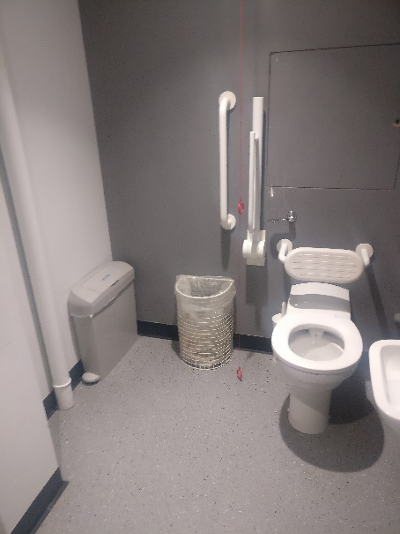
The facility is situated in a non residential area with extensive parking restrictions. Blue Badge holders can park on Gordon Street, Endsleigh Street, and on Endsleigh Gardens. Please check the Blue Badge parking signage carefully before parking.
You can look here for more information.

Accessible features at the venue

Accessible Toilets
There are 2 wheelchair accessible toilets located inside the facility. All are fitted with RADAR locks to prevent abuse by non-disabled people. All reception and security staff hold RADAR keys in case a disabled visitor does not have one with them.
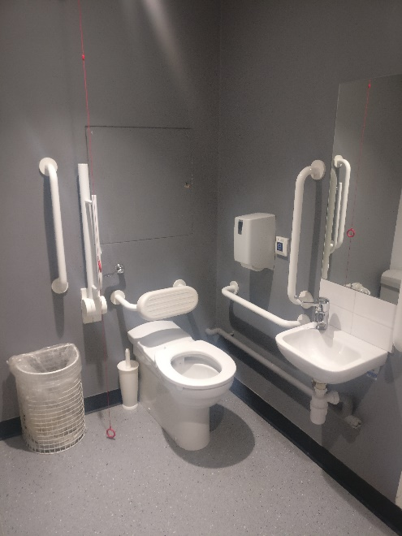
All the wheelchair accessible toilets are unisex and the toilet doors all open outwards. The dimensions of the accessible toilet are 180cm x 235cm (5ft 11in x 7ft 9in). Either a left or right transfer space is available in every wheelchair accessible toilet along with colour contrasted grab rails.
The lateral transfer space is 110cm (3ft 7in). The wash hand basins all have lever type mixer taps. The wheelchair accessible toilets are also fitted with appropriate height mirrors, hand dryers and coat hooks and pull cord emergency alarms.
The 1st accessible toilet is located on the ground floor, to the left of the lifts, and the second accessible toilet is located in the gym on the 3rd floor.
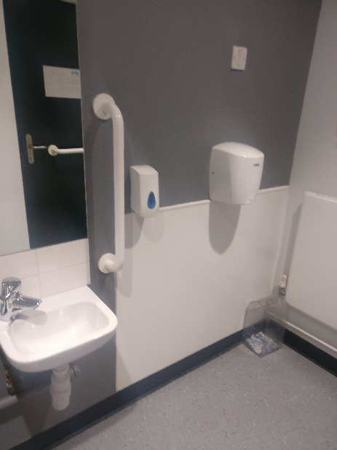
The first three images are of the accessible toilet on the ground floor.

The second two are of the accessible toilet in Bloomsbury Fitness.
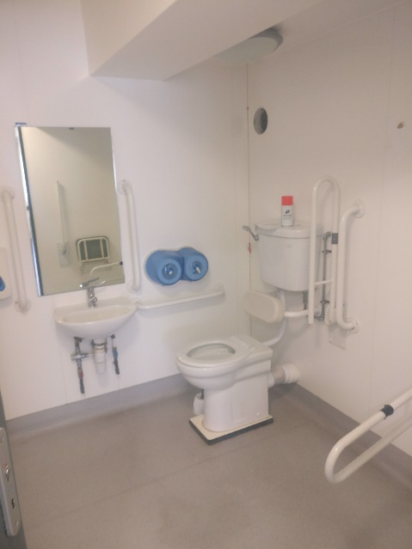

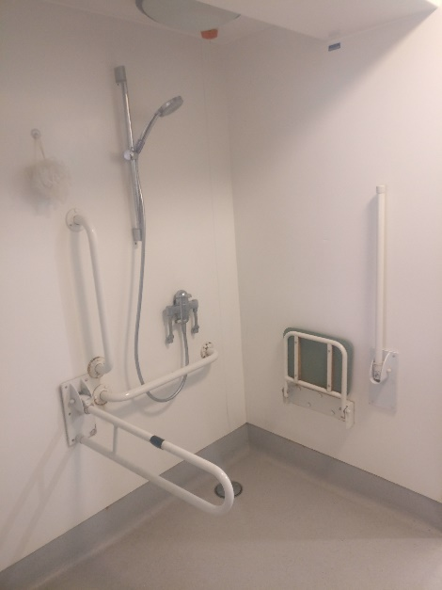
Non accessible Toilets
There are standard male & female toilets next to all the entrances on the ground and first floor. Every standard toilet block contains one cubicle suitable for ambulant disabled supporters.

Tactile Guidance Pathway
There are Tactile Guidance Pathways that our blind and visually impaired members can use to navigate their way into the facility. The pathways begin on the front steps of the Bloomsbury Theatre Building.

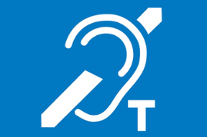
Hearing Induction Loop
There is no hearing induction loop.

BSL User at training/Venue

None.

Contact
The Disability Liaison Team and reception staff can be contacted by:
Address – 15 Gordon Street, WC1H A0Y
Phone 020 7679 7221 (9.30am to 5.00pm Monday to Friday excluding Bank Holidays)
Email: General Enquiries, SU.Bloomsbury Fitness Reception <su.bf-reception@ucl.ac.uk>

